The Syntax Surgeon

AI-Powered Code Fixer & Conversational Assistant Using IBM Granite 3.3 2Model

Project Description:

The Syntax Surgeon is an intelligent conversational AI platform designed to provide both chatbot interaction and advanced Python code analysis. It is powered by the IBM Granite 3.3 2B Instruct model and implemented through the interactive interface of Gradio. The system aims to make AI assistance more accessible by enabling powerful conversational support and automated code fixing without requiring external API keys.

This platform integrates natural language conversation with intelligent Python code detection, analysis, and correction. By utilizing Python’s AST module for syntax validation, advanced regular expression techniques for identifying code patterns, and formatting tools such as Black (Python formatter) and autopep8, the system automatically detects errors, corrects indentation issues, balances brackets, and formats Python code according to best practices.

The Syntax Surgeon also includes conversation history management and the ability to export interactions into professional documentation formats such as PDF or TXT. Users can interact with the system through a clean and user-friendly interface while customizing model parameters like temperature, max tokens, and top-p to control the response behavior.

By combining conversational AI with advanced code analysis, local model deployment, and flexible configuration options, Syntax Surgeon provides a powerful yet accessible platform for both general AI conversations and technical programming assistance. Its modern interface and comprehensive features transform AI support into a practical tool for learning, debugging, and improving python code.

Scenarios:
Scenario 1: Python Developer Debugging Support
A Python developer working on an application encounters syntax mistakes and improper formatting in the code. The developer pastes the code into the Syntax Surgeon chatbot. The system automatically identifies that the input is Python code, analyzes the syntax problems such as missing brackets or incorrect indentation, and corrects them using tools like Black and autopep8. The chatbot then returns the corrected version of the code. If the developer asks for clarification, the chatbot explains the functionality of the code in detail. The entire interaction is stored and can be exported as a PDF for reference or documentation.
Scenario 2: Educational Coding Assistant
In a programming course, an instructor introduces the Syntax Surgeon chatbot as an additional learning tool for students. Students can ask questions about programming concepts, submit incomplete code snippets, and receive corrected code along with explanations. The chatbot keeps track of the conversation history and provides context-aware responses. Teachers can download the complete chat history as a PDF file to evaluate student progress and provide structured feedback.
Scenario 3: Code Review and Quality Analysis
A software quality assurance team uses the Syntax Surgeon chatbot to review code from development repositories. Developers paste code snippets into the chatbot, which automatically checks for formatting problems and common Python errors. The system also suggests improvements and explains problematic coding patterns. The team can share conversation links with colleagues and export the analysis reports as PDF documents for project documentation.
Scenario 4: Internal Code Formatting Tool
A development organization deploys the Syntax Surgeon chatbot as an internal utility for code analysis and formatting. Since the model runs locally, the team does not need to depend on external APIs, ensuring data security and reducing operational costs. Developers can access the chatbot simultaneously, and all conversations are stored locally for auditing and internal reference. Sensitive source code remains secure within the company infrastructure.

Scenario 5: Collaborative Programming Assistance
During pair programming sessions, developers use the Syntax Surgeon chatbot to receive real-time suggestions and explanations for their code. They can paste code snippets, receive corrections, and discuss improvements with the chatbot. The conversation history acts as a record of the coding discussion, which can later be exported as a PDF document and shared with the broader development team for knowledge sharing
Architecture Overview :
The Syntax Surgeon chatbot is designed using a modular architecture that integrates IBM’s Granite language model with Python code analysis utilities. The system focuses on providing accessible AI assistance without requiring external API keys. It ensures high-quality code formatting and intelligent debugging through automated tools while maintaining a user-friendly interaction interface built with Gradio. The architecture also supports conversation tracking, allowing users to store, export, and manage chat history effectively.

Core Technologies :
• Python 3.8+ – Primary programming language used to build the application logic and code analysis modules.
• IBM Granite 3.3 2B Instruct – Advanced language model responsible for generating conversational responses and explanations.
• Gradio 4.0+ – Framework used to create the interactive web interface for the chatbot.
• Hugging Face Transformers – Library used to load and run the AI model for inference tasks.
• PyTorch – Deep learning framework that powers model computation.
• Black – Automatic Python formatter used for maintaining consistent coding style.
• autopep8 – Tool used to automatically correct Python style issues based on PEP 8 standards.
• ReportLab – Library used to generate professional PDF reports of chat conversations.
• Google Colab – Cloud environment used for running the model with GPU support.
• Regular Expressions (Regex) – Used for detecting Python code patterns within user input.

Pre-Requisites :

Software Requirements:
• Python 3.8 or higher version installed.
• Google Colab account for running the model with GPU support.
• pip package manager for installing dependencies.
• CUDA 11.8 or higher for GPU acceleration (optional for local setup).
• Modern web browser such as Chrome, Firefox, Safari, or Edge.
• Stable internet connection for downloading the model and enabling sharing features.

Knowledge Requirements:
• Basic knowledge of Python programming concepts.
• Familiarity with Python syntax including imports and functions.
• Understanding of how conversational AI or language models operate.
• Basic knowledge of the Gradio interface framework.
• Experience using Hugging Face models and pipelines.
• Basic usage of Google Colab notebooks.
• Awareness of Python coding style guidelines such as PEP 8.

Hardware Requirements:
• GPU recommended for faster processing (NVIDIA RTX or Tesla).
• Minimum 8 GB RAM, with 16 GB preferred for smoother performance.
• Around 2 GB of available storage space for model files and libraries.
• Display resolution of at least 1024×768 for proper interface viewing.
• Google Colab can provide free GPU resources such as T4 or P100.

Project Workflow :

Phase 1: Environment Preparation and Model Setup
Activity 1.1: Dependency Installation and Environment Configuration
- Prepare a requirements.txt file listing all necessary libraries.
- Configure the development environment in Google Colab with GPU support enabled.
- Install required packages such as Gradio, Hugging Face Transformers, PyTorch, Black, autopep8, and ReportLab.
- Check whether CUDA support is available for GPU acceleration.
- Verify that the PyTorch installation correctly detects GPU resources.
Activity 1.2: IBM Granite Model Configuration
- Implement a configuration class named ChatbotConfig to manage model settings.
- Specify the model identifier ibm-granite/granite-3.3-2b-instruct.
- Define default generation parameters such as temperature, maximum token limit, and top-p sampling.
- Add automatic detection to determine whether the model should run on GPU or CPU.

Phase 2: Python Code Detection and Correction Engine
Activity 2.1: Code Identification Mechanism
- Develop a detect_python_code() function using regular expression patterns.
- Identify Python function definitions using the def keyword.
- Detect class declarations using the class keyword.
- Recognize module import statements.
Activity 2.2: Syntax Checking and Code Validation
- Implement a check_syntax() function using Python’s AST parser.
- Analyze the structure of the code to locate syntax issues.
- Provide detailed error messages including line numbers.
- Ensure the system handles different types of syntax errors gracefully.

Activity 2.3: Automated Code Correction
- Develop fix_code_indentation() to standardize spacing and indentation.
- Implement fix_code_brackets() to automatically correct unbalanced brackets.
- Apply Black as the primary formatter to enforce Python style standards.
- Use autopep8 as a backup formatter when Black fails.
- Integrate all correction functions into a central fix_python_code() workflow.

Phase 3: Conversational AI Processing
Activity 3.1: Conversation History Tracking
- Maintain a conversation_history list to store session interactions.
- Save each message with role identifiers such as user or assistant.
- Preserve conversation context for multi-turn dialogue.
- Provide an option to clear or reset conversation history.
Activity 3.2: AI Response Generation
- Implement generate_response() to process user queries using the AI model.
- Allow adjustable parameters including temperature, maximum tokens, and top-p.
- Process and format model outputs before displaying them.
- Include exception handling to manage possible inference errors.

Phase 4: User Interface Development
Activity 4.1: Chat Interface Creation
- Build an interactive chatbot interface using Gradio.
- Add a text input field for user queries.
- Include a send button for submitting messages.
- Provide parameter control sliders for adjusting generation settings.
Activity 4.2: Export and Download Features
- Implement download_txt() to export chat conversations in text format.
- Develop download_pdf() using ReportLab to generate structured PDF reports.
- Enable file download options within the interface
Activity 4.3: Sharing and Collaboration Tools
- Implement generate_share_link() for integration with Pastebin.
- Connect with the Pastebin API to upload chat conversations.
- Generate shareable links for collaboration.
- Enable optional sharing through social media platforms.

Phase 5: System Integration, Testing and Deployment
Activity 5.1: Deployment in Google Colab
- Integrate model loading with the interface initialization process.
- Test the full chatbot interaction pipeline.
- Verify the functionality of code detection and correction modules.
- Check system behavior under different error conditions.
Activity 5.2: Functional Testing
- Evaluate the chatbot’s ability to respond to general conversation queries.
- Test Python code detection with different coding patterns.
- Verify automatic correction of incomplete or incorrect code.
- Ensure conversation history management works correctly.
- Validate parameter adjustment features such as temperature and token limits.
- Test TXT and PDF export functions with multiple messages.
- Confirm that Pastebin sharing links are generated successfully.

Technical Architecture
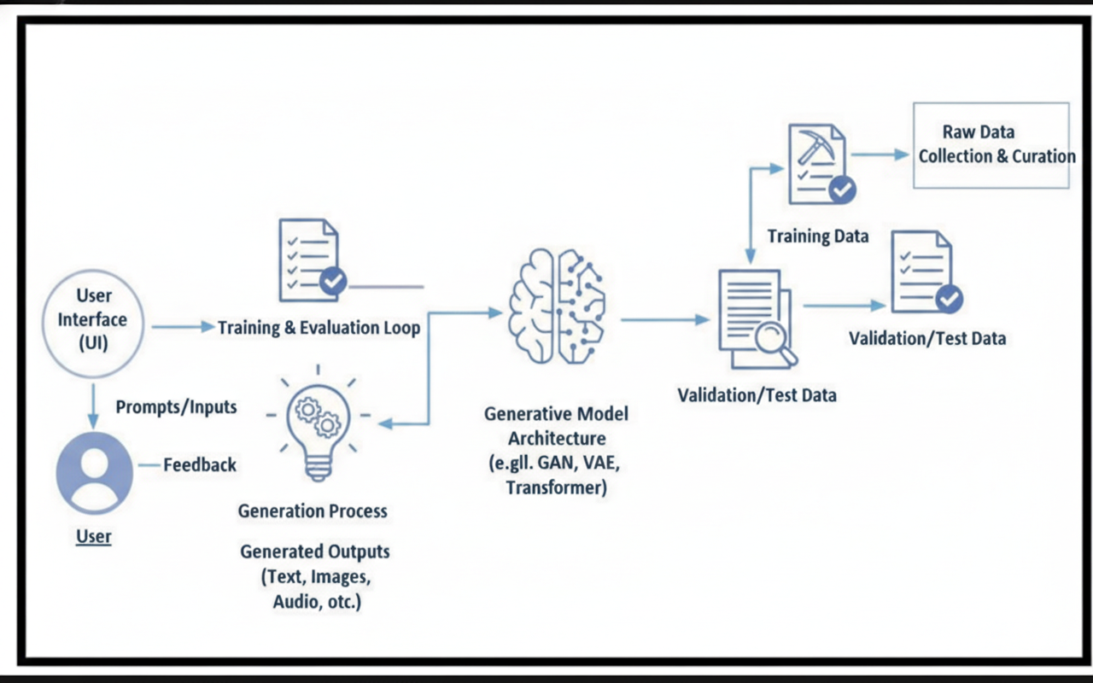

Project Structure:
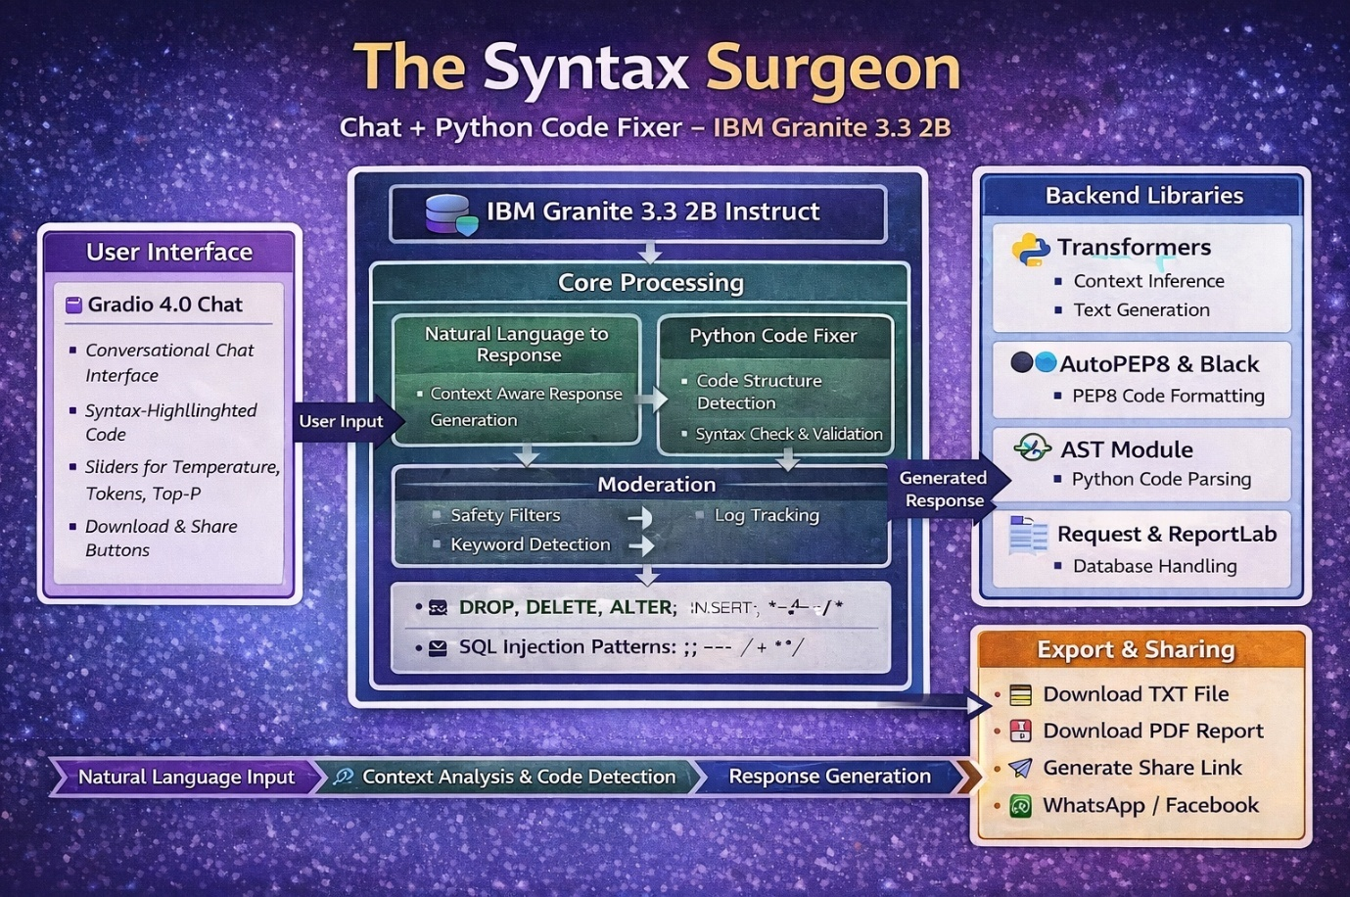

Milestone 1: Environment Setup and Model Configuration
Activity 1.1: Dependency Installation
Create a requirements.txt file including the following libraries:
- gradio==4.41.0
- transformers==4.35.0+
- torch==2.0.0+
- black==24.1.1
- autopep8==2.1.0
- reportlab==4.0.7
- requests==2.31.0
Note: Library versions may vary depending on CUDA compatibility.

Install via:pip install -r requirements.txt

Cell-1:code reference(hint:click on image and you an copy paste from comment)

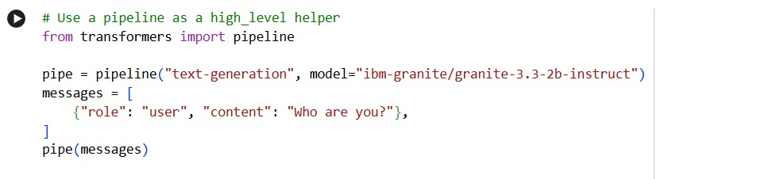
Cell-2:code reference((hint: click on image and you can copy paste from Comment)

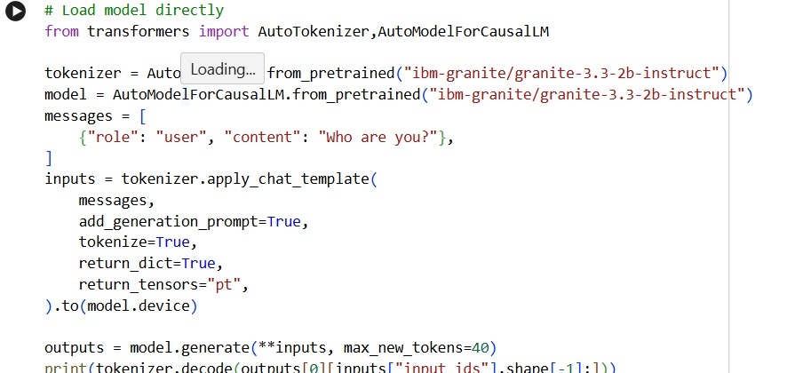
Cell-3: Code reference (hint: click on image and you can copy paste from Comment)

For Google Colab:
!pip install -q gradio transformers torch black autopep8 reportlab requests

Cell-4: Code reference (hint: click on image and you can copy paste from Comment)

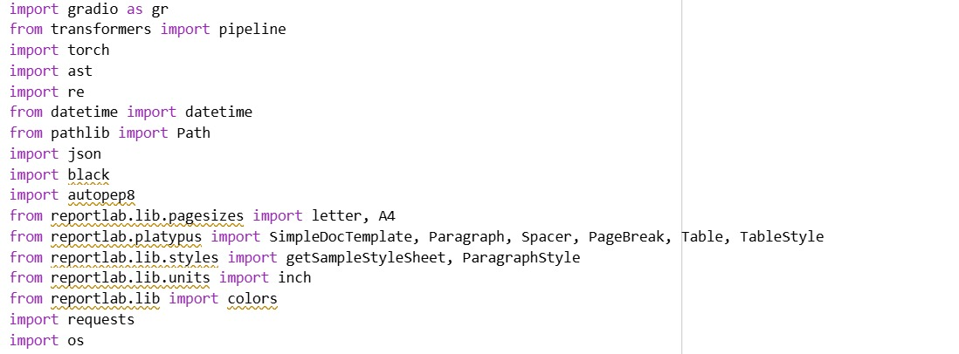
Cell-5: Code reference (hint: click on image and you can copy paste from Comment)

Activity 1.2: ChatbotConfig Class
Define a configuration class named ChatbotConfig to manage the model parameters used by the chatbot system.
Example:
class ChatbotConfig:
MODEL_NAME = "ibm-granite/granite-3.3-2b-instruct"
DEFAULT_TEMP = 0.7
DEFAULT_MAX_TOKENS = 256
DEFAULT_TOP_P = 0.95
This configuration performs the following functions:
- Specifies the IBM Granite 3.3 2B Instruct language model for generating responses.
- Sets a default temperature value to control randomness in responses.
- Limits the maximum number of tokens generated for each response.
- Uses top-p sampling to improve response diversity while maintaining coherence.
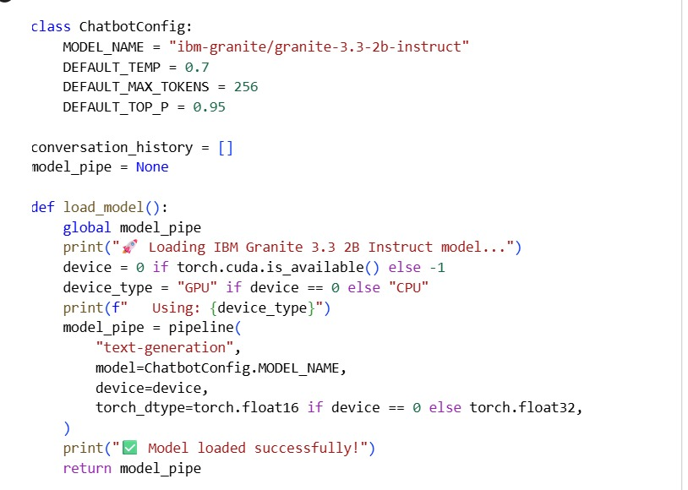
Cell-5: Code reference (hint: click on image and you can copy paste from Comment )
MILESTONE 2: Python Code Analysis & Fixing Engine

Activity 2.1: Code Detection System
Implement detect_python_code() with regex patterns:
Patterns detected:
1. def pattern: r'def\s+\w+\s*\('
→ Detects function definitions
2. class pattern: r'class\s+\w+'
→ Detects class definitions
3. import patterns:
→ r'import\s+\w+' (import statements)
→ r'from\s+\w+\s+import' (from-import)
4. Control flow patterns:
→ r'if\s+.*:' (if statements)
→ r'for\s+.*\s+in\s+' (for loops)
→ r'while\s+.*:' (while loops)
Example:
Input: "def add(a, b): return a + b"
Output: True (Python code detected)
Cell-5: Code reference (hint: click on image and you can copy paste from Comment)

Activity 2.2: Code Validation & Syntax Checking
Implement check_syntax() using Python AST:
def check_syntax(code):
try:
ast.parse(code)
return True, None
except SyntaxError as e:
return False, f"Syntax Error (line {e.lineno}): {e.msg}"

Features:
- Uses Python's built-in AST parser
- Catches syntax errors accurately
- Returns line numbers for errors
- Provides clear error messages
Example:
Input: "def add(a, b) return a + b"
Output: (False, "Syntax Error (line 1): expected ':' after function definition")
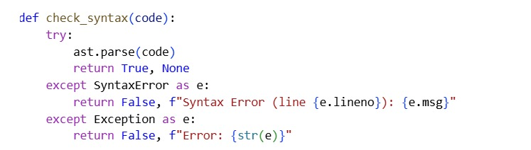 Cell-5: Code reference (hint: click on image and you can copy paste from Comment)

Activity 2.3: Code Fixing & Formatting
Implement comprehensive code fixing:
1. fix_code_indentation():
- Removes trailing whitespace
- Converts tabs to 4 spaces
- Normalizes line endings
2. fix_code_brackets():
- Counts open/close brackets: ( ) [ ] { }
- Adds missing closing brackets
- Handles nested structures
3. format_code():
- Primary: Uses Black formatter
- Fallback: Uses autopep8
- Enforces PEP 8 compliance
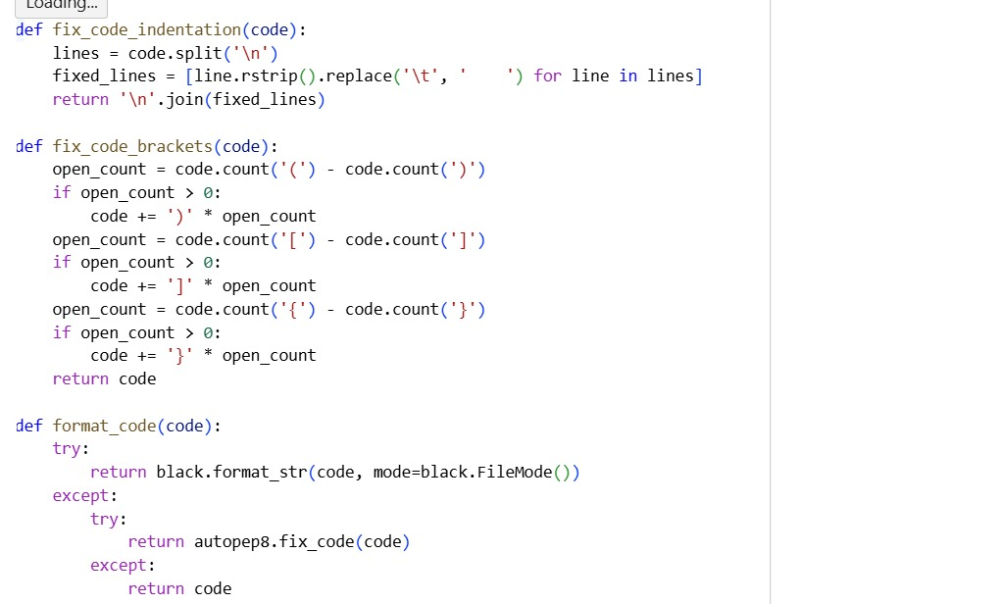
Cell-5: Code reference (hint: click on image and you can copy paste from Comment)
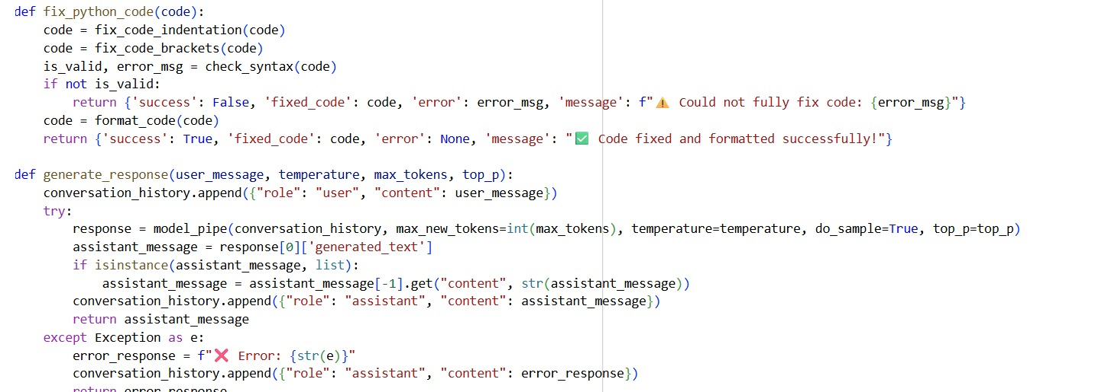
Cell-5: Code reference (hint: click on image and you can copy paste from Commen

MILESTONE 3: Conversational AI & Response Generation
Activity 3.1: Managing Conversation History
To support continuous interaction, the system maintains a structured conversation history list that stores all user and assistant messages. This enables the model to understand previous context and generate meaningful responses in multi-turn conversations.
conversation_history = []
Message Structure
Each message in the history follows a standardized format:
{
"role": "user" | "assistant",
"content": "message text"
}
Key Capabilities
- Stores the entire conversation context
- Enables multi-turn interactions
- Allows conversation reset when required
- Supports exporting and sharing conversation logs
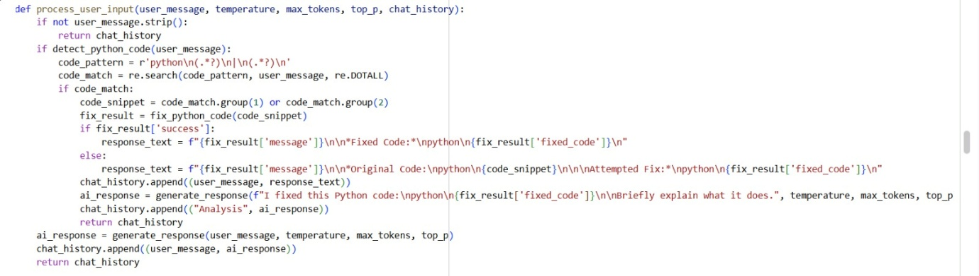
Cell-5: Code reference (hint: click on the image and copy from the comment)

Activity 3.2: Model Inference and Response Generation
The system generates responses using a dedicated function that processes the user's input and interacts with the language model pipeline.
Function Implementation
def generate_response(user_message, temperature, max_tokens, top_p):
conversation_history.append({"role": "user", "content": user_message})

response = model_pipe(
conversation_history,
max_new_tokens=int(max_tokens),
temperature=temperature,
do_sample=True,
top_p=top_p
)

# Process and return response
Important Generation Parameters
- Temperature:
Controls randomness of responses.
  - 0.1 → more deterministic
  - 1.0 → more creative
- max_tokens:
Limits the length of generated output.
Range: 50 – 1024 tokens
- top_p (Nucleus Sampling):
Controls diversity by selecting from the most probable tokens.
Range: 0.1 – 1.0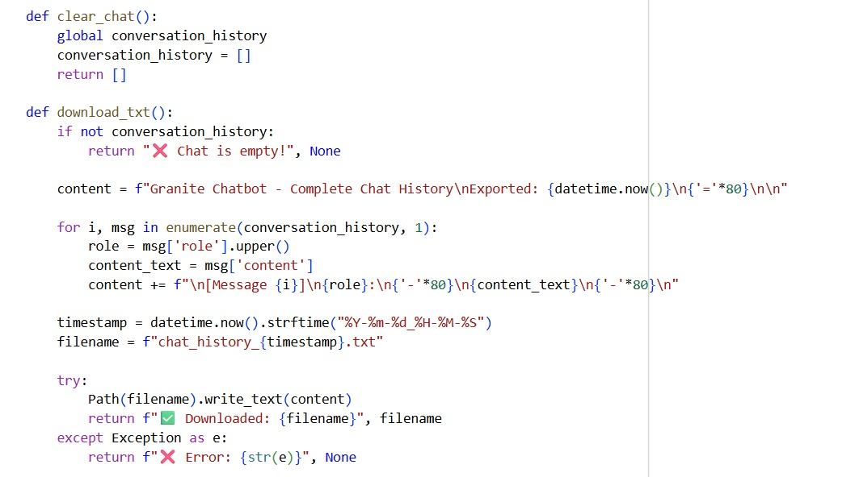
Cell-5: Code reference (hint: click on the image and copy from the comment)

MILESTONE 4: Gradio Interface & Features
Interface Layout Overview
The application interface is built using Gradio, providing a clean and interactive chat environment.
LEFT COLUMN – Main Chat Area
Contains the core conversation interface:
- Chatbot component (height: 400px)
- Message input textbox (2 lines)
- Send button
- Adjustable generation parameters:
  - Temperature slider (0.1 – 1.0)
  - Max Tokens slider (50 – 1024)
  - Top-P slider (0.1 – 1.0)

RIGHT COLUMN – Control Panel
Additional controls and utilities are provided here:
- Clear Chat button
- Download TXT option
- Download PDF option
- Generate Share Link
- Status display textbox
- File download components
This layout ensures that the main conversation area remains clean while advanced controls are easily accessible.

Activity 4.1: Chat Interface Implementation
Chatbot Features
The chatbot interface provides several useful capabilities:
- Displays the complete conversation history
- User messages appear on the left
- Assistant responses appear on the right
- Includes a copy button for easy sharing of code
- Supports scrolling for long conversations

Message Processing Workflow
The chat system follows the steps below:
- The user enters a message or pastes code.
- The user clicks Send or presses Enter.
- The system processes the message by:
  - Detecting whether the input contains code
  - Generating an appropriate response
  - Updating the conversation history.
- The chatbot interface refreshes to display the new messages.
- Users can adjust generation parameters at any time.
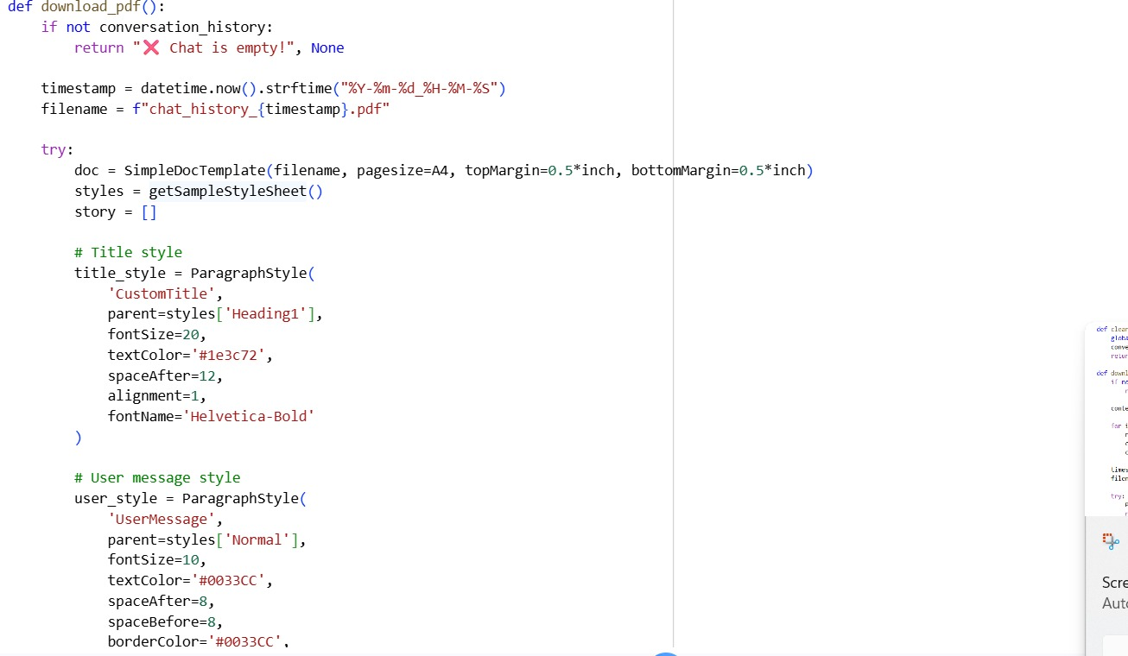
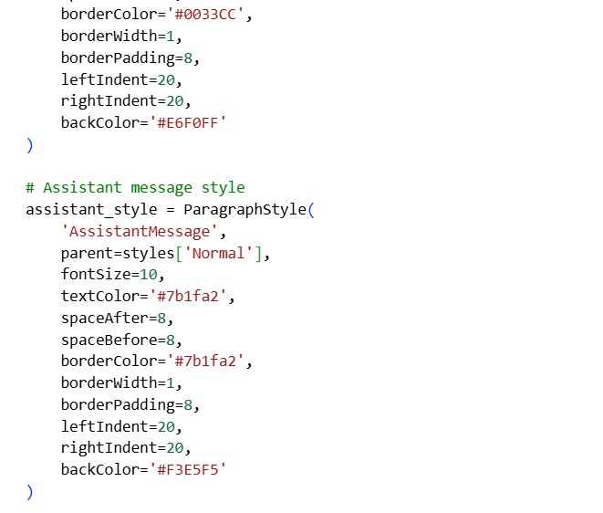Cell-5: Code reference (hint: click on the image and copy from the comment)

Activity 4.2: Export Functionality
The system includes multiple export options for saving and sharing conversations.
TXT Export
This option generates a plain text file containing the full conversation.
Features include:
- Messages stored with timestamps
- Clear role labels (USER / ASSISTANT)
- Simple format suitable for email or documentation
- Preserves the entire conversation history

PDF Export (ReportLab)
The PDF export creates a well-formatted professional document.
Key features:
- Styled message containers
- Color-coded messages
  - Blue → User
  - Purple → Assistant
- Automatic pagination
- Metadata information such as:
  - Export timestamp
  - Total message count
- Clean typography for readability
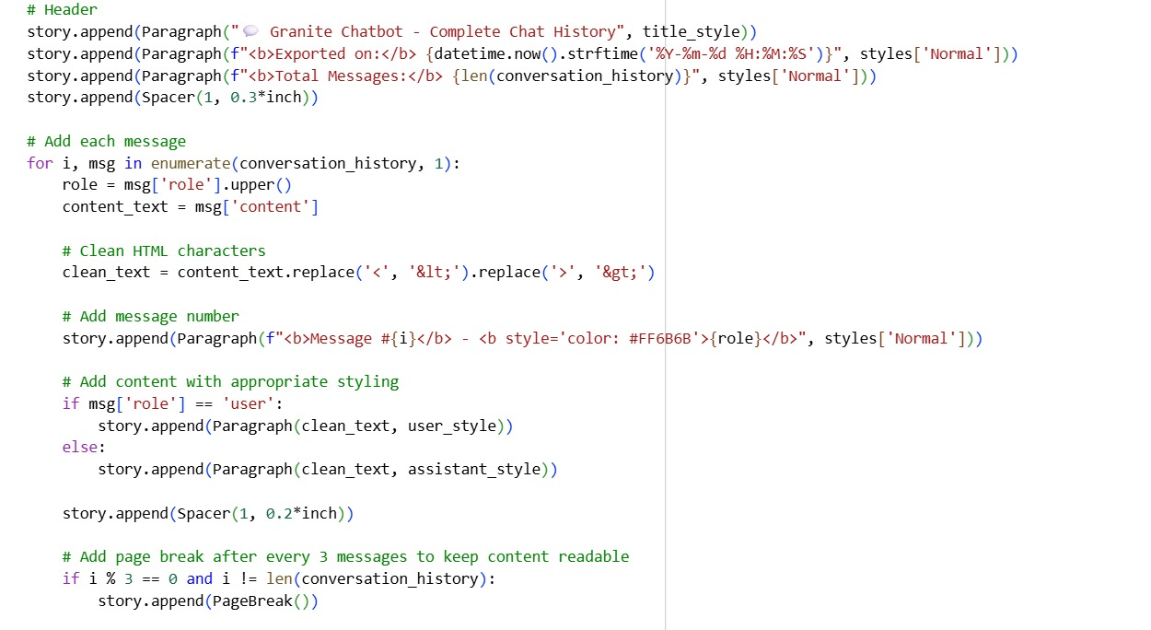
Cell-5: Code reference (hint: click on the image and copy from the comment)

Activity 4.3: Sharing and Collaboration
Pastebin Integration
The platform integrates Pastebin to allow easy sharing of conversation logs.
This feature enables users to generate a shareable link containing the chat history.
Capabilities include:
- Uploading conversation data to Pastebin
- Creating public or private URLs
- Facilitating team collaboration and review
- Simplifying discussion sharing with peers
Additional features:
- URL expiry configuration
- Syntax highlighting for code
- Automatic chat summary generation
- Easy sharing on social platforms (Twitter, Facebook, etc.)
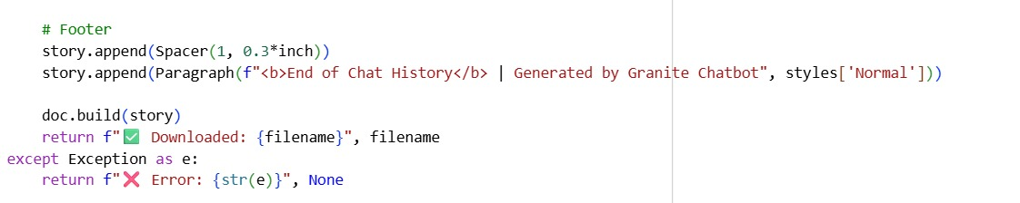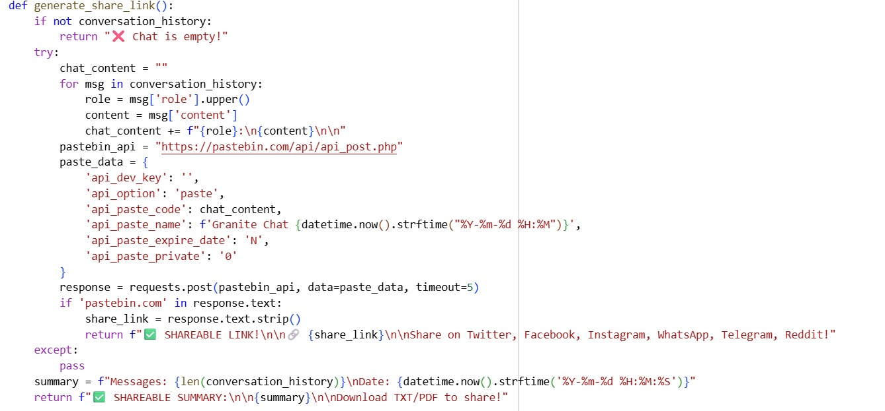
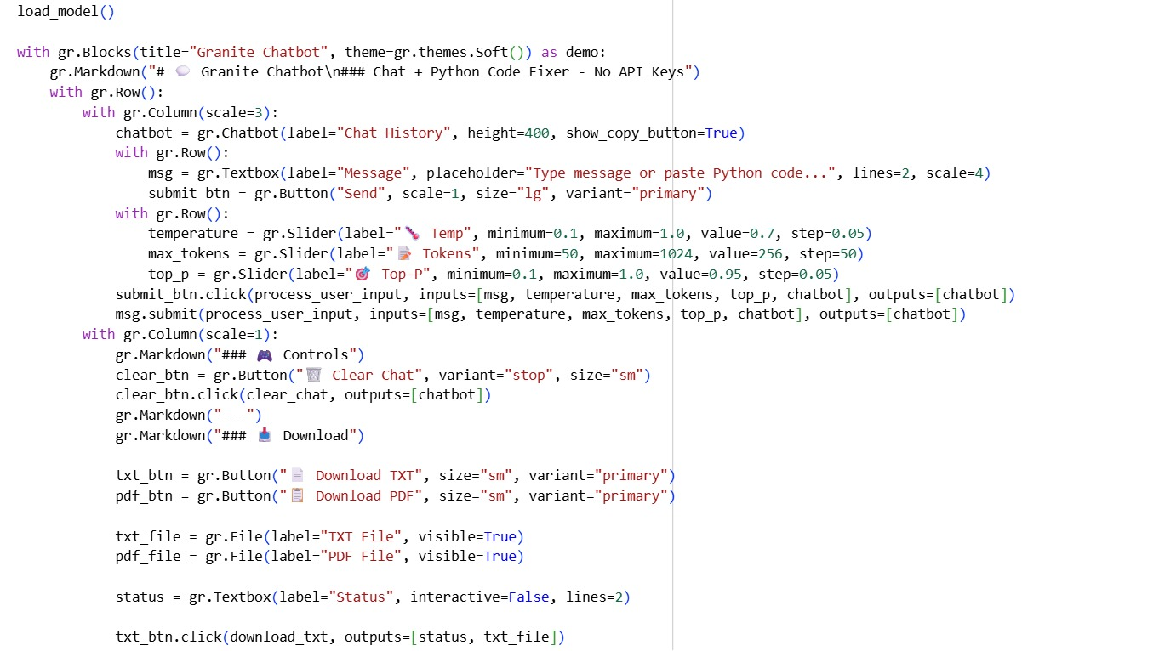Cell-5: Code reference (hint: click on the image and copy from the comment)

MILESTONE 5: Testing & Deployment
Activity 5.1: Google Colab Deployment
Deployment Steps
- Prepare the Colab Environment
  - Enable GPU support (T4 or higher)
  - Install all required dependencies
  - Verify CUDA availability
- Load the Model
  - Download the IBM Granite model from Hugging Face Hub
  - Run a sample prompt to test inference
  - Confirm response quality
- Launch the Gradio Interface
  - Configure public sharing
  - Generate a public access URL
  - Test interface functionality
- Final System Testing
  - Verify code detection
  - Test automatic code fixing
  - Validate conversation flow
  - Test export options
  - Verify shareable links
- Documentation
  - Record the generated public URL
  - Document model size and inference performance
  - Prepare a user guide

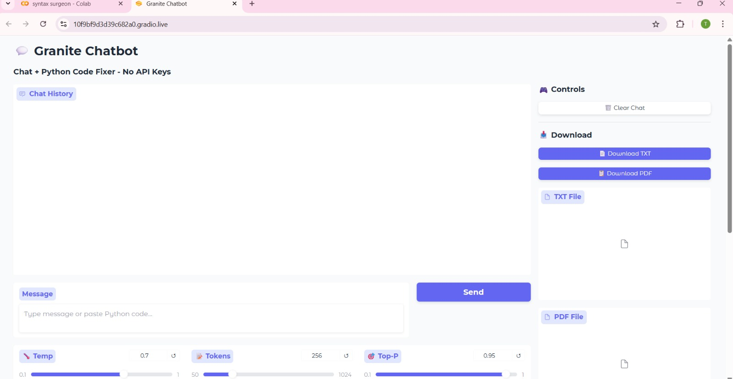

Activity 5.2: Functional Testing
Test Case 1 – Normal Conversation
User Query:Explain list comprehensions in Python
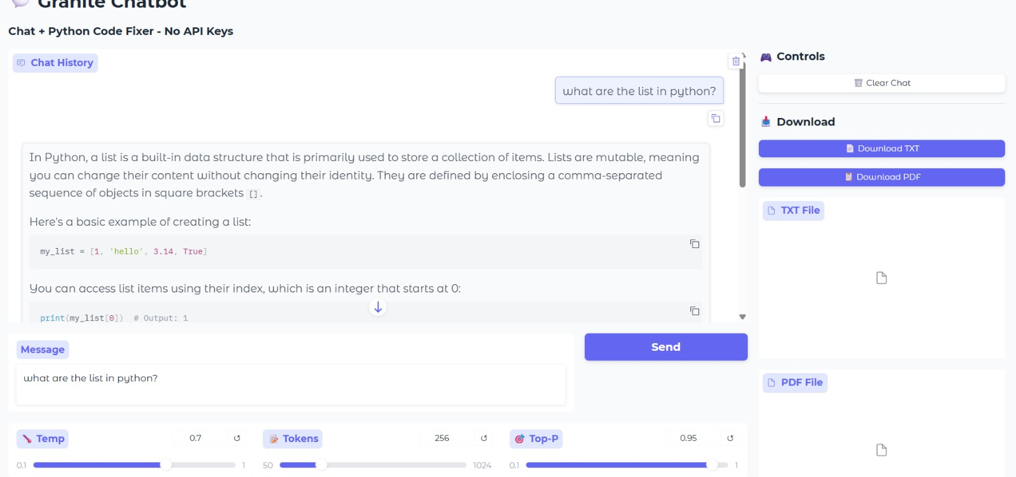
Status:
✅ Conversational functionality works correctly.

Test Case 2 – Code Fixing
User Input:
def greet(name
print(f"Hello, {name}")
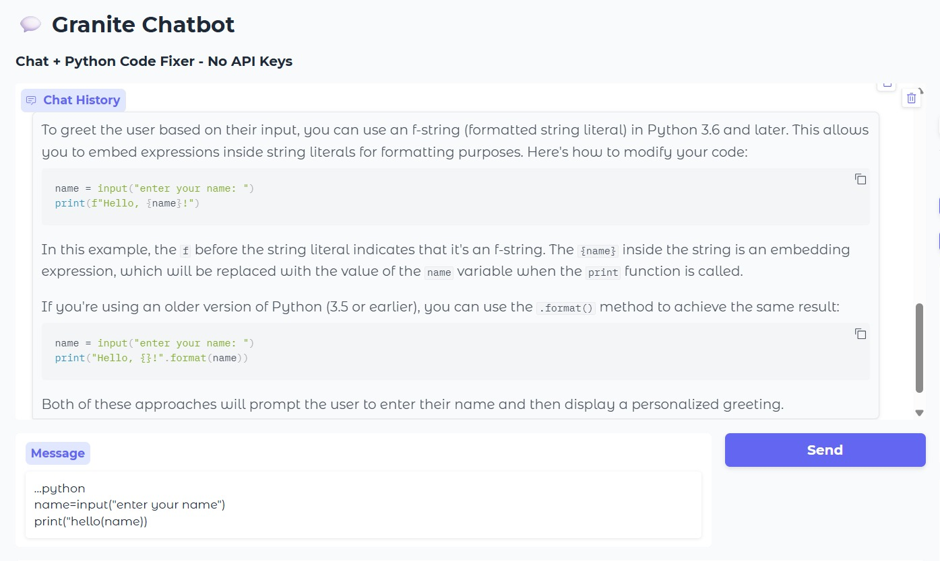
Status:
✅ Code correction feature works successfully.

Future Enhancements:
The system architecture is modular, allowing future expansion with advanced capabilities such as:
- Support for additional programming languages (JavaScript, Java, C++)
- Integration with code analysis tools like pylint and flake8
- Multilingual explanation and translation
- Integration with development platforms such as GitHub and GitLab
- Voice input and speech output features
- Domain-specific model fine-tuning
- Real-time streaming responses
- Advanced debugging suggestions

Conclusion:
The Syntax Surgeon successfully demonstrates an intelligent conversational AI system that combines the capabilities of the IBM Granite language model with automated Python code analysis and correction.
By integrating transformer-based language models, intelligent code analysis techniques, and structured conversation management, the platform offers both general conversational support and technical programming assistance.
The system also showcases the feasibility of local AI model deployment, eliminating reliance on external APIs while maintaining high-quality responses. With features such as configurable response generation, automatic code fixing, conversation tracking, and professional export options, the platform provides a powerful tool for developers, students, and collaborative teams.
Overall, The Syntax Surgeon serves as a strong foundation for building advanced AI-powered development assistants and educational programming tools.

